Git Modification Verification Check

Chase Hammock

Professor Smith

AWS IT Practicum Journal

Fall 2024

Module 1 – Introduction to Cloud Computing with AWS

Amazon Web Services (AWS) provides on-demand delivery of server space such as storage, processing, or remote systems over the internet. AWS is well known for its pay-as-you go method which is especially important for many companies needs such as running digital storefronts so that a company doesn’t have to pay for more processing power all year round just to ensure their site functions on a day like black Friday. Allowing people to use infrastructure more as a service is another thing services like AWS does well. Rather than having to purchase hardware and upgrade it as it gets out of date, AWS provides the service, maintains the hardware, covers utilities in data centers, and provides easier opportunities to expand than if a company was working with internal hardware.

* IaaS – Infrastructure as a Service (More control over IT Resources)
* PaaS – Platform as a Service
* SaaS – Software as a Service (Less control over IT Resources)

The IaaS provides a solution for those who need lots of control over the systems such as managing what runs on individual systems. AWS provides the infrastructure such as an instance, server, or group of systems and the company can then develop or select software or applications to run on said systems. PaaS is purchasing a platform that can serve a company needs often times with pre-built modules that can easily be added to systems AWS Lambda is Amazon’s Platform as a Service solution and Google has Google App Engine. These services are good for rapid deployment and easier use by automating or not requiring more in-depth management of server resources or provisioning available capacity. Software as a Service solutions would be like what my employer uses. Club Essentials is a software-based solution that is provided to work over their own cloud systems and runs basic point of sale functionality for us and is a pre-built solution for us to manage a roster of people and process their payments.

Cloud Computing Deployment Models

* Cloud
* Hybrid (Partially on the cloud and use of on-site equipment)
* On-premises (Private Cloud

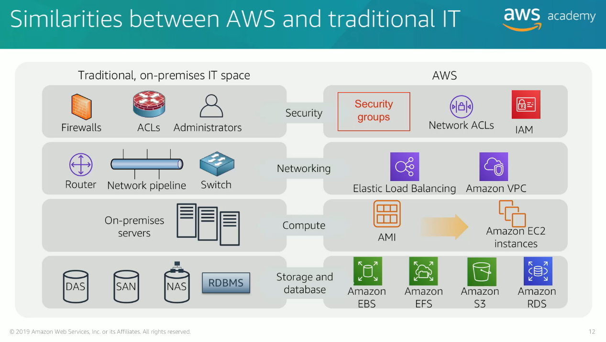

Summary of Similarities between AWS and traditional IT systems:

* AWS’s use of security groups, network access control lists, and identity control management are like firewalls and traditional permission systems that determine who or what systems can access certain pieces within the IT system.
* Elastic load balancing and virtual private cloud are the networking systems such as routers and switches.
* Amazon Machine Images are used to initialize instances and can be compared to servers using virtual machines to utilize one systems resources effectively between multiple parties while keeping information separated.
* Elastic Block Store & Elastic File System are storage that can be attached to the instances or virtual machines.
* Simple Storage Service (S3) is file storage similar to network attached storage that many people could access and work from to allow more mobility in sharing files and keeping data accessible even if an individual users device were to be lost.
* Relational Database Service is a relational database equivalent.

Each of these services are designed to allow a complete transition to AWS by fulfilling all the needs of a traditional on-site system. I was quite shocked to see how many different types of solution for storage specifically are needed to serve the different needs of AWS customers and how much control over systems and networks can be provided to be an effective replacement for traditional IT systems. I am interested to know if AWS’s S3 system is an effective replacement for the many uses of traditional network attached storage that provide rapid access to small and large files. An internet outage or slower connections seem like it would hamper the effectiveness of S3 and would still require the use of on site storage for situations such as video editing where many editors need access to files in real time.

Amazon’s economies of scale and the existing staff they have maintaining systems in data centers can make usage of AWS more cost effective than running private cloud infrastructure. This is combined perfectly with the pay-as-you-go so that there is no guessing what capacity needs to be purchased. Before taking this class, the key thing I heard about AWS is its flexibility for any size of company with its pay-as-you-go system. Small or large, systems developed in house, or use of existing software and services all are key benefits of Amazon Web Services it would seem.

Web services are pieces of software available over the internet that use standardized formats and languages for request and responses of application programming interfaces (API) interactions. AWS provides many services that integrate to provide a complete sophisticated and scalable solution. Services can be selected from many categories and service types to fulfill the needs of different companies, business units, or teams. AWS scalability and security prowess has been mentioned in various articles and is why some of the most important IT systems such as government and military IT and storage systems turn to Amazon to do it all. They are one of very few that meet the security requirements to store classified documentation.

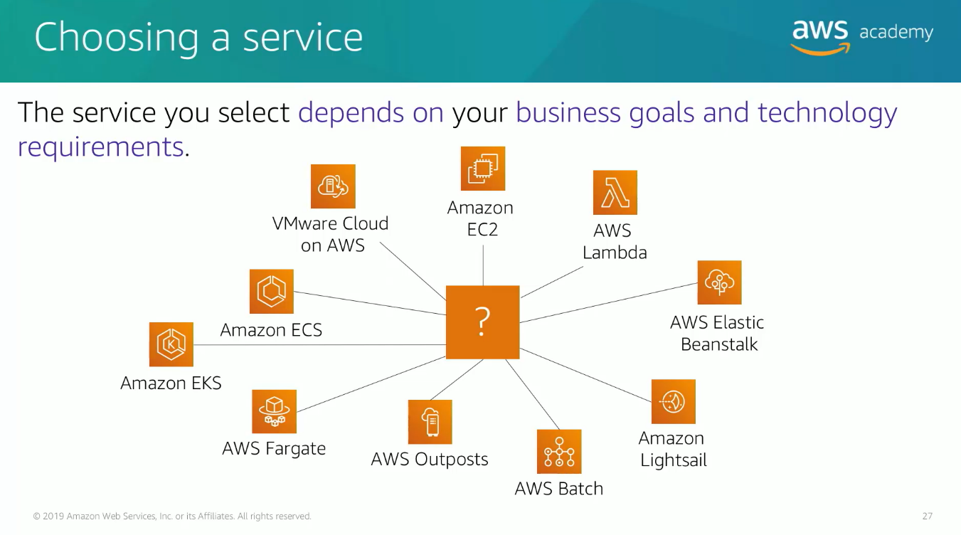

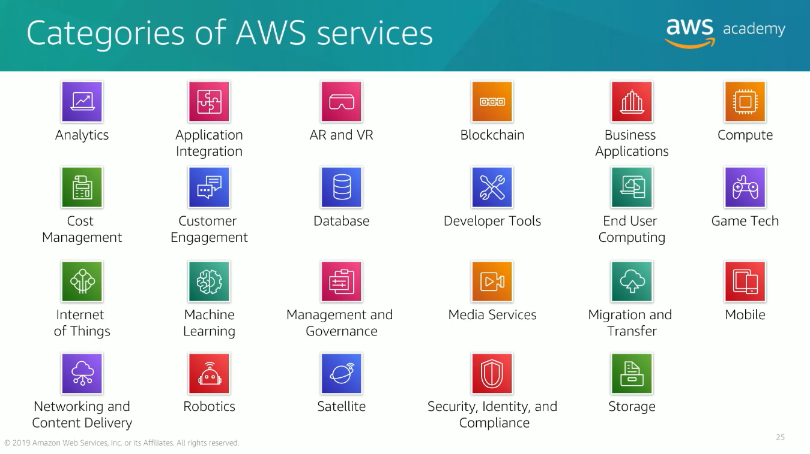

Choosing compute options:

* Amazon EC2 – Use for complete control over AWS compute resources and infrastructure.
* AWS Lambda – Used for running code and not have to manage provision services
* AWS Elastic Beanstalk – Provision a service that manages and scales web applications automatically.
* Amazon Lightsail – Cloud platform for launching web applications.
* AWS Batch – Used to run large numbers of batch workloads often non-interactive jobs that are sequential such as payroll, modeling, and consistent billing that need to be reliable and done quickly.
* AWS Outposts – Used to run AWS infrastructure on premises.
* Amazon Elastic Containers Services, Amazon Elastic Kubernetes Service or AWS Fargate can be used to run microservices architecture or containers.
* VMware Cloud on AWS used for on-premises server platforms that are to be migrated to AWS.

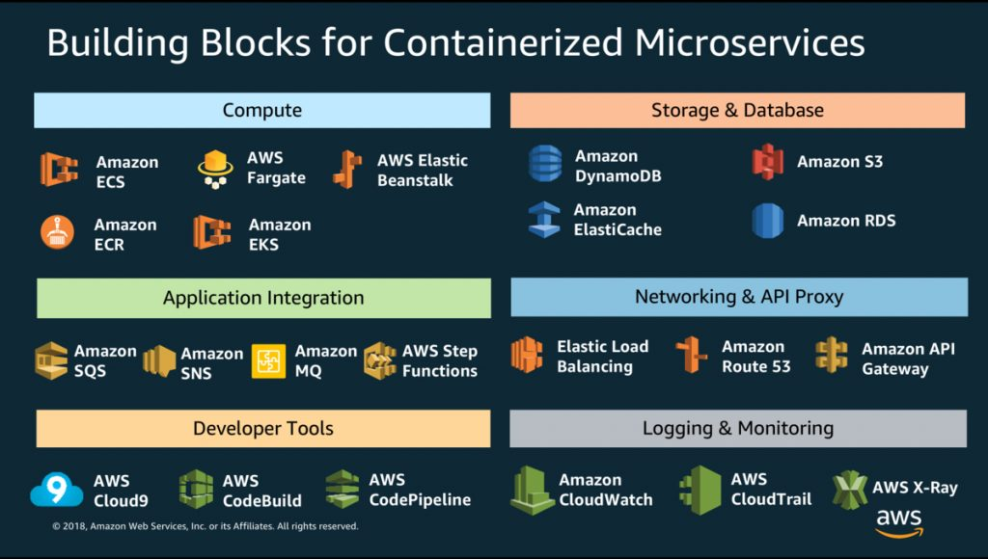

AWS services can be interacted with by using the AWS management console which is a graphical user interface (GUI), a command line interface (AWS CLI), or a software development kit (SDK) which allows access directly from code by using a provided package to integrate into Python, Java, C#, and various other popular coding languages.

AWS Cloud Adoption Framework (AWS CAF) is used to transition or accelerate businesses use of AWS for innovation and cloud transformation. Stakeholders, divisions within a company, and individuals all need to support many changes to make a successful adoption. Identification of best practices and areas in need of improvement are key points to focus on in the framework.

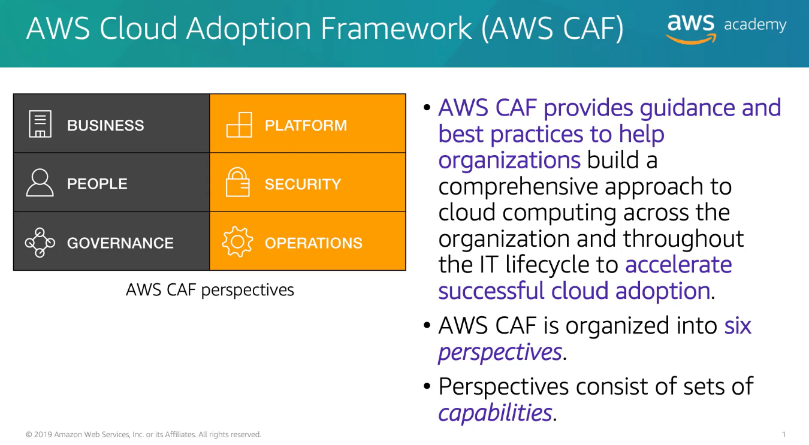

Module 2 – Billing and Pricing Philosophy

Compute, storage, and data transfer are all key cost factors. Compute charges by time used and can vary in pricing based on the options used. Storage charged by storage used in standard metrics such as gigabyte or terabyte. Data transfer charged by outbound traffic in standard metrics such as gigabyte or terabyte.

No charge for inbound traffic or data put into system.

Pay for what you use.

Pay less when reserving what is needed.

Pay less as you pay for more and grow your AWS usage and pay less as AWS grows as scale.

No large upfront expenses.

Tiered payment structure – economies of scale, pay less per gigabyte the more you use. Tiered pricing. In effect for services such as AWS storage services like S3, Elastic Block Store, or Elastic File System.

AWS has lowered pricing 75 times (as of September 2019). Focus is lowering cost of doing business.

Custom pricing is available for unique, high volume customers.

AWS free tier to run free solution for a year free of charge and become familiar with AWS. Some services also offered with no charge: IAM, Elastic Beanstalk, Amazon VPC.

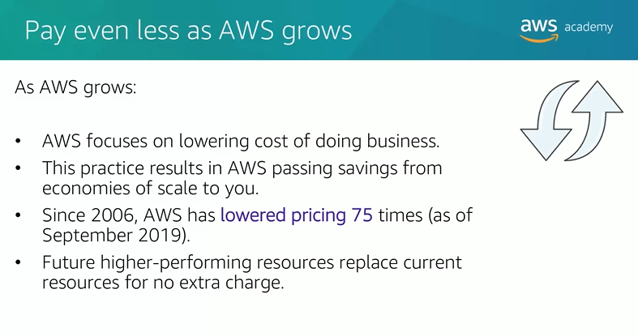

Comparison of how AWS vs traditional infrastructure works. On-site installation with inclusion of capital expenses and costs to scale up with little or no cost reduction for scaling down because equipment, staffing, and contracts are already fixed costs for existing resources.

Cloud infrastructure is billed for what is used and allows easy estimation of costs and scaling down reduces costs and easy expansion without the need for as much long-term planning.

TCO: Total cost of ownership: “Financial estimate to help identify direct and indirect costs of a system”

Most costs are upfront and easily calculated for cloud services. Often fixed by time or other usage numbers.

On-site needs to consider power, storage, equipment, network, and facilities to name a few.

Compare costs of running infrastructure environment and on-site costs to compare with running same workload in a cloud solution. Generally used for budgeting.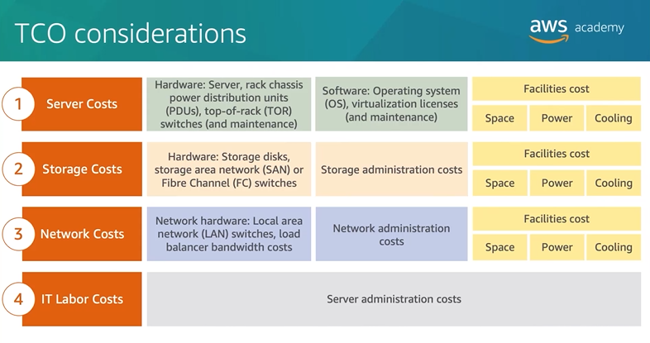

AWS Pricing Calculator can be used to estimate costs and model solutions needed before building and buying services.

AWS benefits businesses with reduced spending on compute, storage, networking, and security needs as these wouldn’t need to be handled by a team on-site. Lessened need for operational costs and disaster recovery.

Soft benefits can include better reach globally, better productivity, and higher customer satisfaction.

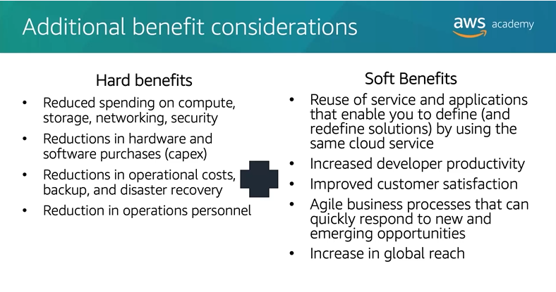

Delaware North case study: Migrating from their 205 servers to AWS to optimize resources, save money, react quicker to the market, and operate more efficiently. Security compliance tasks were no longer required in the same way since AWS manages the security of the equipment.

AWS Organizations:

Sometimes each department or team needs an AWS account like to track billing and costs used by teams or strategic business units (SBUs). AWS Organizations is a tool to consolidate many AWS accounts into a tree with branches being parts of the organization or parts of teams.

OU= Organizational Unit

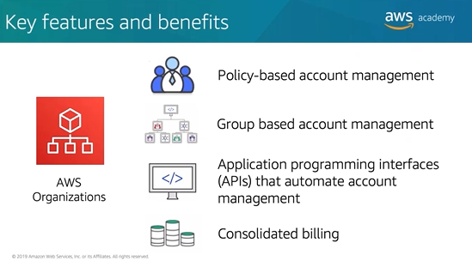

AWS Organizations doesn’t replace Identity and Access Management IAM system.

Individual accounts can have permissions limited such as no access to certain AWS services. These are all organizational control policies that need to be tested to ensure developers and managers have appropriate access to tools they need but aren’t provided with unneeded sensitive information.

AWS Billing and Cost Management:

Service used to pay AWS bill, monitor costs, and budget future costs and plan ahead.

Filtering and grouping are available along with time granularity to analyze cost.

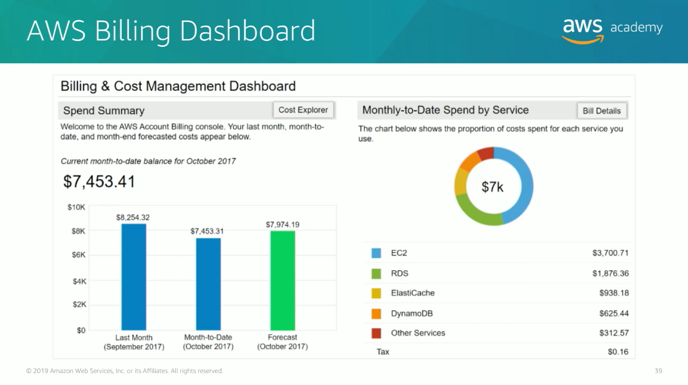

Spend Summary shows previous months spending and also forecasts the future spending. AWS also provides the AWS Budgets tool, AWS Cost and Usage Reports, and AWS Cost Explorer. The cost explorer page breaks down where costs are coming from such as EC2 Instances, Elasticsearch Service, and DynamoDB for the prior months.

AWS Budets can be used to set notifications alerting the business of when they have reached their budget and are going over budget.

Trends, such as higher costs in select categories, forecasted costs, current costs, and comparison to budgets are all key pieces to the AWS billing console.

AWS Technical Support Plans:

AWS support provides tools for current and future needs to support customers experimentation, planning, and deploying systems and services. Technical Account Manager (TAM) provides proactive guidance and are the primary point of contact. Only available in enterprise support plans.

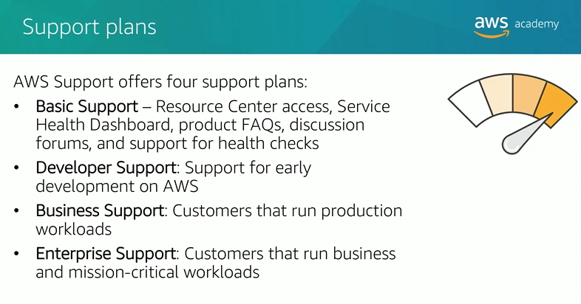

AWS Support Concierge is a senior customer service agent assigned to provide personalized support for assistance with complex and important workloads. Part of premium support plans.

Severity Levels:

Low, Normal, High, Urgent, & Critical. For fast response times in urgent or critical scenarios, a business plan or enterprise plan should be in use. Critical would be scenarios where the business as a whole is at risk.

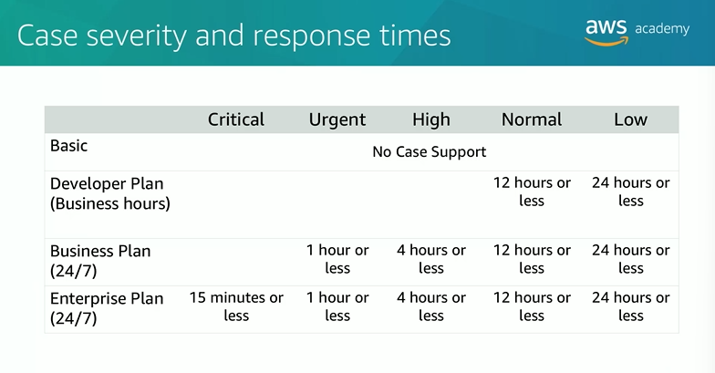

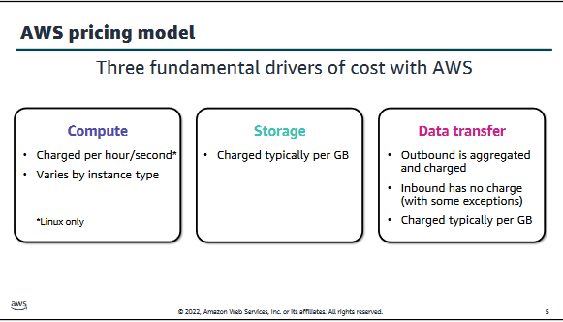

I was surprised about the number of price decreases AWS has received. Many businesses would optimize costs and keep that margin as profit with an already successful service but Amazon’s unique mindset means they continue to grow as the most dominate force in the industry rather than be a strong competitor with more profit per customer.